
Department of Electronics and Telecommunication
A. Y. 2022-23 SEM - I
T. Y. B. Tech.
Internet of Things Lab
EXPERIMENT 7
Title: Study of web based application through ESP32
Objective: To develop a web application through ESP32
Software used: Arduino IDE
Arduino Cloud
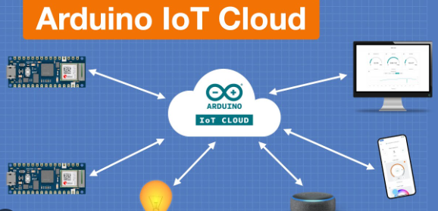
Arduino IoT Cloud is an application that helps makers build connected objects in a quick, easy and secure way. You can connect multiple devices to each other and allow them to exchange real-time data. You can also monitor them from anywhere using a simple user interface.
Arduino IoT Cloud is fully integrated in the Arduino Create ecosystem, you will be able to generate a template code in Arduino IoT Cloud and then edit and upload it to your board using the Arduino Web Editor.

Theory:
Adding variables to the cloud:
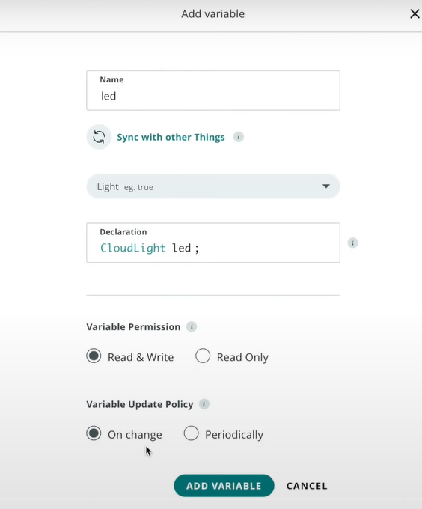
Selecting device:
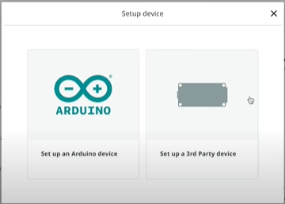
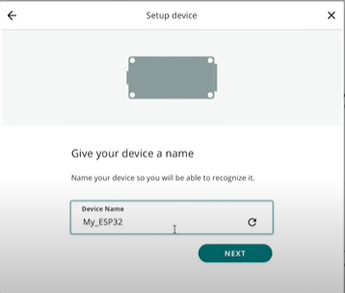
Adding Network:
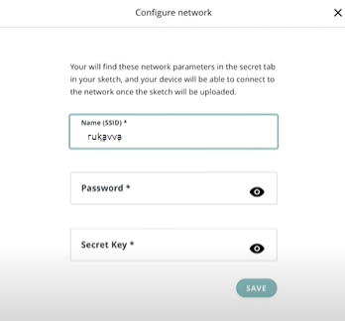
Configuring Dashboard:
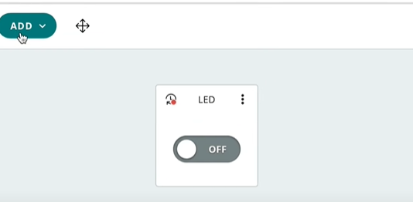
Algorithm / code :
CloudLight lED;
CloudTemperatureSensor temperature;
CloudRelativeHumidity humidity;

Variables which are marked as READ/WRITE in the Cloud Thing will also have functions
which are called when their values are changed from the Dashboard.
These functions are generated with the Thing and added at the end of this sketch.
*/

#include "thingProperties.h"

void setup() {
// Initialize serial and wait for port to open:
Serial.begin(9600);
pinMode(2, OUTPUT);

// This delay gives the chance to wait for a Serial Monitor without blocking if none is found
delay(1500);

// Defined in thingProperties.h
initProperties();

// Connect to Arduino IoT Cloud
ArduinoCloud.begin(ArduinoIoTPreferredConnection);

/*
The following function allows you to obtain more information
related to the state of network and IoT Cloud connection and errors
the higher number the more granular information you’ll get.
The default is 0 (only errors).
Maximum is 4
*/
setDebugMessageLevel(2);
ArduinoCloud.printDebugInfo();
}

void loop() {
ArduinoCloud.update();
// Your code here

}

/*
Since LED is READ_WRITE variable, onLEDChange() is
executed every time a new value is received from IoT Cloud.
*/
void onLEDChange() {
// Add your code here to act upon LED change
if (lED == 1)
{
digitalWrite(2, HIGH);

}
else
{
digitalWrite(2, LOW);
}
}

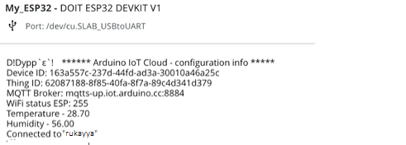
Output:
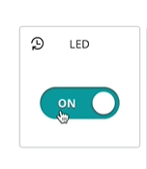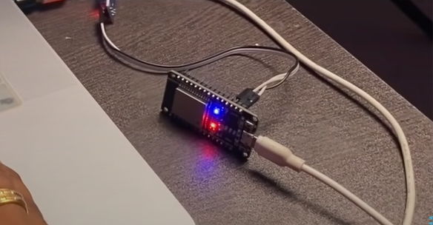
Conclusion:
- Arduino Cloud is a free platform that can be used to connect things with internet in IoT.
- Configuration of variables for cloud is done automatically using arduino cloud
- Dashboard setup is used to actually handle the actuators and sensors connected to the arduino
- Large variety of different libraries are included in the this platform.

